Project Title: Machine Learning Based Predictive Model for Urban Livability Using Environmental and Socioeconomic Indicators.
Research /Project Area : Data Science (Machine Learning)
Abstract : CityMatch is an advanced machine learning-based recommendation system designed to assist users in navigating the complexities of urban relocation in Delhi. By integrating multi-source geospatial and environmental data, the system provides a data-driven framework for identifying optimal residential areas based on personalized liveability preferences. The study leverages high-resolution datasets, including seasonal Air Quality Index (AQI) from the CPCB, real-time traffic congestion metrics from the TomTom API, and rental price distributions from over 5,900 verified listings. To handle geospatial outliers and varying data scales, a pipeline utilizing percentile capping and MinMaxScaler normalization was implemented. K-Means clustering ($K=4$) was applied to categorize 72 Delhi neighbourhoods into distinct liveability tiers, ranging from budget-friendly peripheral zones to premium central hubs. The core of the system is a weighted sum scoring engine that translates subjective user priorities into objective Match Scores. Deployed via an interactive Streamlit dashboard, CityMatch effectively bridges the gap between complex urban big data and non-technical end-users, facilitating more informed, healthier, and economically efficient relocation decisions.

Prototype / Systemwork flow:
Visual Pipeline Representation
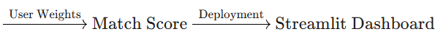
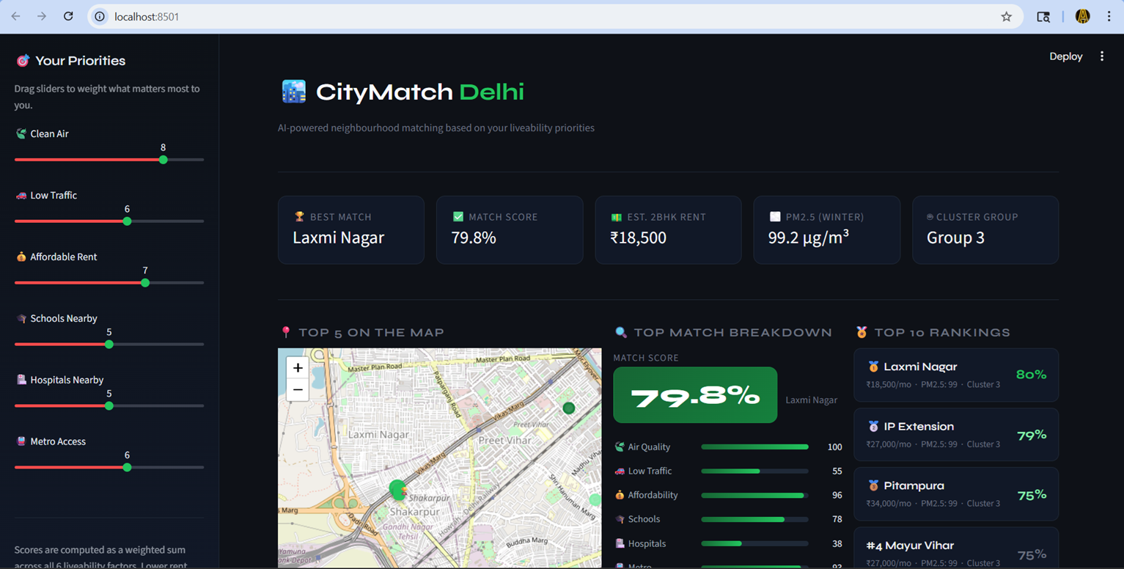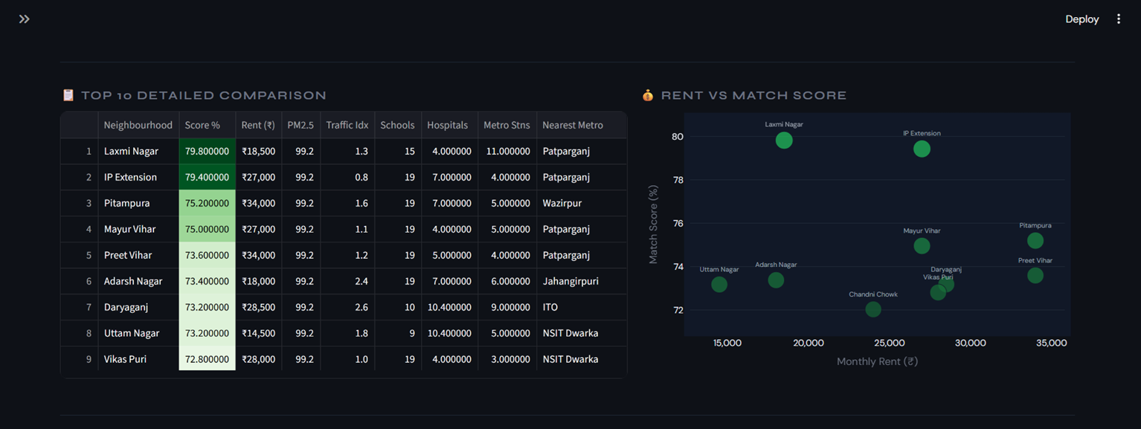

Name of Student(s) : Aakarsh Pab/Sagar Singh Bisht
Programe(s): B. Tech. – CSE-DS (2022-26)/ B. Tech. – CSE-DS (2022-26)
Name of Supervisor(s) : Dr. Shuchi Mala
Relevant Publication / Patent / Copyright:
A.Pab, S.Bisht, S.Mala, " Machine Learning Based Predictive Model for Urban Livability Using Environmental and Socioeconomic Indicators ", ICT4SD Conference 11th International Conference on ICT for Sustainable Development.(Submitted)

